CSA1503-Cloud computing and big data analytics
Experiment-8
Name – Ramya S S
Regno – 192421226
Create a simple cloud web application for student counselling system using any Cloud Service Provider to demonstrate SaaS with the fields of student name, age, address, phone, subjects studied, Year of passing, percentage of marks, domain interest, etc.
INPUT
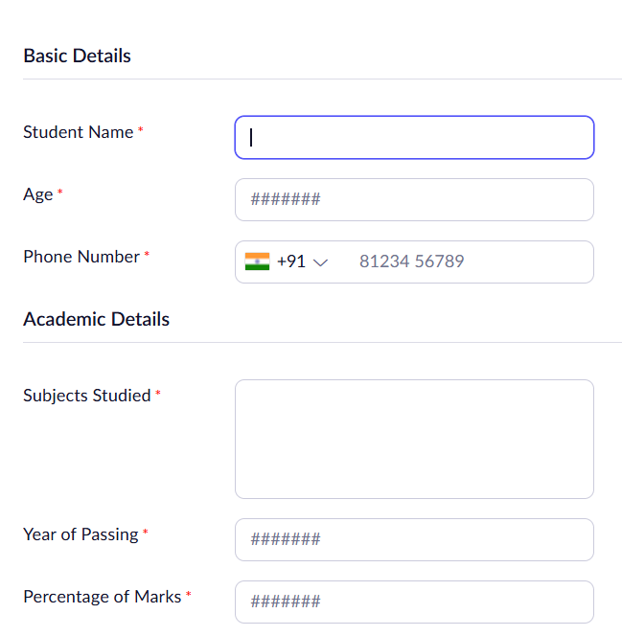
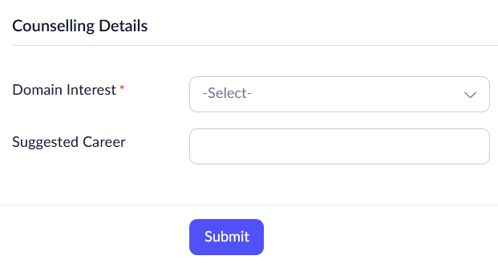

OUTPUT
